 

Department of Computer Science & Information Technology

III Year,V Semester(Batch 2022-2026)

Lab Record Submission of

Linux (Lab)

Subject Code – CSIT-505

Submitted to: Submitted by:

Prof. Nidhi Nigam Manish Makode

0827CI221087

**Overview of the Linux File System**

**Introduction**

The Linux file system is a crucial component of the Linux operating system, responsible for organizing and managing data on disk drives. Unlike other operating systems, Linux employs a unique hierarchical structure that helps maintain file organization and accessibility.

**File System Structure**

**1. Root Directory (/)**

At the top of the Linux file system hierarchy is the root directory, denoted by /. All other files and directories are organized beneath this root.

**2. Key Directories**

* **/bin**: Essential command binaries. Contains fundamental command-line utilities like ls, cp, and mv.
* **/boot**: Contains boot loader files and the Linux kernel. This is crucial for the system startup process.
* **/dev**: Device files that represent hardware components. For example, /dev/sda refers to the first hard disk.
* **/etc**: Configuration files for system and application settings. This includes user account information, network configurations, and more.
* **/home**: User home directories. Each user has a subdirectory here, such as /home/username.
* **/lib**: Essential shared libraries and kernel modules required by system binaries.
* **/media**: Mount points for removable media like USB drives and CDs.
* **/mnt**: Temporary mount points for mounting file systems.
* **/opt**: Optional application software packages.
* **/srv**: Data for services provided by the system, such as web or FTP servers.
* **/tmp**: Temporary files created by users and applications. This directory is often cleared on reboot.
* **/usr**: User-related programs and data. It contains subdirectories like /usr/bin for user commands and /usr/lib for libraries.
* **/var**: Variable files like logs and databases that change in size and content.

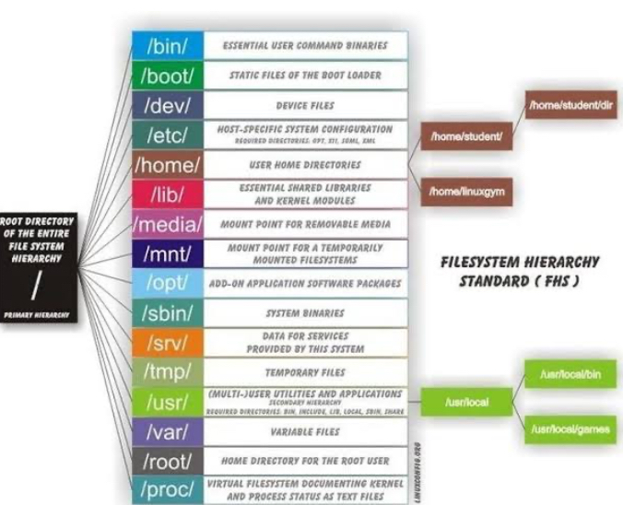

Figure 1Linux file system

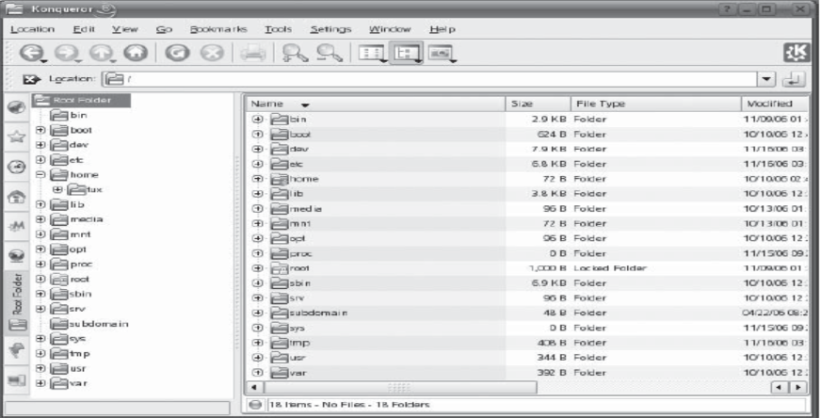

Figure 2linux file system (b)

**File Types**

Linux supports several types of files, including:

* **Regular files**: Contains user data.
* **Directories**: Special files that contain lists of other files and directories.
* **Special files**: Includes device files and named pipes.
* **Symbolic links**: Pointers to other files or directories.

**File Permissions**

Linux implements a robust permission system to enhance security. Each file and directory has associated permissions that dictate access levels:

* **Owner**: The user who owns the file.
* **Group**: A set of users that have shared access to the file.
* **Others**: All other users on the system.

**Permission Types**

* **Read (r)**: Permission to read the file.
* **Write (w)**: Permission to modify the file.
* **Execute (x)**: Permission to execute a file (for scripts and programs).

Permissions are represented in a three-character string format, such as rwxr-xr--, where the first three characters represent owner permissions, the next three represent group permissions, and the last three represent permissions for others.

**Mounting File Systems**

Linux allows multiple file systems to be mounted at different points in the directory tree. The mount command is used to attach file systems. For example:

bash

**Common File System Types**

Linux supports various file system types, including:

* **ext4**: The most common file system used in modern Linux distributions, known for its performance and reliability.
* **XFS**: A high-performance file system suitable for large-scale data storage.
* **Btrfs**: A newer file system designed for advanced features like snapshotting and dynamic resizing.
* **FAT32/exFAT**: Used primarily for removable media due to broad compatibility.